

**King Abdul-Aziz University**

**Faculty of Computing and Information Technology**

**Computer Science Department**

*Fall 2020*

**CS 665 Project Report**

**Training Management System**

*(Programmer’s Academy Website)*

*Submitted to:*

*prof. Arwa Alaama*

*Student name:*

*Ghoroub Bostagi*

*2000910 (*[*gbostaji@kau.edu.sa*](mailto:gbostaji@kau.edu.sa)*). (0567160002)*

*Maryam Alamoudi*

*2000404 ([mahmadalamoudi@stu.kau.edu.sa](mailto:mahmadalamoudi@stu.kau.edu.sa)) (0500679997)*

*Sumayya Azzony*

*2001768 ([ssaeedazzony@stu.kau.edu.sa](mailto:ssaeedazzony@stu.kau.edu.sa) ) (0553210032)*

Table of Contents

Table of figures: 3

**Introduction:** 4

**Tools used in the project:** 5

**Programming languages**: 6

**Data base type of Programmer’s Academy** 6

**Programmer’s academy images and design:** 7

**Tasks for each member:** 23

# Table of figures:

Figure 1: use case diagram for Programmer's academy system 5

Figure 2: Home page above side 8

Figure 3: Home page down side 9

Figure 4: Register page 10

Figure 5: log in page 10

Figure 6: page after logging in successfully. 11

Figure 7: Services page 12

Figure 8: about us page 13

Figure 9: Find more about programming languages 14

Figure 10: Contact us page 15

Figure 11: Programmer's academy trainers 16

Figure 12: Programmer's academy trainees 17

Figure 13: Explore all courses page 17

Figure 14: Admin' programmers academy permissions 18

Figure 15: creates session page for admin 18

Figure 16: invite and remind trainees by admin 19

Figure 17: Header for all webpages 19

Figure 18: Footer for all webpages 19

# **Introduction:**

As a required project in Internet Technology course CS 665 developing a website, this report explained Programmer’s academy web-based application which built it.

***Programmer’s academy*** is a web-based application that allows users to accomplish different tasks in managing programming languages training sessions. Any visitor to the website can register, display our services, contact us, know more about the website, check latest news about programming languages around the world, know more about programming languages provided such as its description, its use, and link to its organization, explore the added courses, and access to Programmer’s academy’s accounts on social media such as Twitter, Facebook, YouTube, etc. Programmer’s academy has two type of users, admin and trainee. Both type of users has the ability to log in and log out from the system and do what the website visitor does. Admin can create a new programming language session, invite trainers and trainees, send remainder to them. On the other hand, trainee can register in such a session.

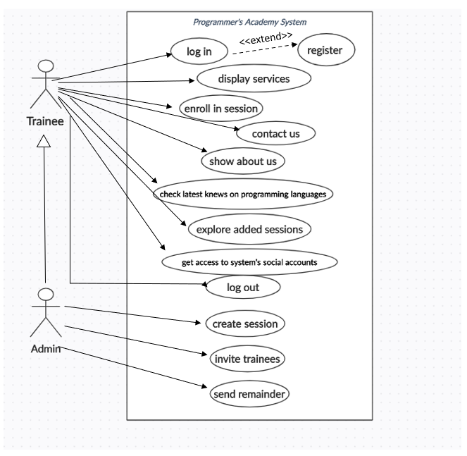

Figure 1: use case diagram for Programmer's academy system

# **Tools used in the project:**

1. **Atom** which is a free modern and approachable text editor, allows **multi-line and multi-file editing.**
2. **Chrome browser:** afree Internet browser officially released by [Google](https://www.computerhope.com/jargon/g/google.htm). It allows website developer to closely analyze all the visual, interactive, and technical components of website locations.
3. **GitHub:** We shared our codes on GitHub. So, we used fetch and pull features on it to download new data from a remote repository.

**Our GitHub page:** <https://ghoroubbostaji.github.io/ProgrammersAcademy/>

**Programming languages**:

* HTML (Hypertext Markup Language), as foundation for any website.   
  *Note: we saved our html pages as* ***ejs*** *extensions to enable generating an HTML web page depending on some variables in our program.*
* CSS (Cascading Style Sheet): to enable tag languages such as HTML to be styled.
* JS and jQuery: to identify interactivity and what actions take place.

**Data base type of Programmer’s Academy:**

Non-Relational (NoSQL: Not only Structured Query Language) Data base used in this website which is MongoDB. As data needed connecting in MongoDB and **node js** which is the local host for the front pages, Mongoose tool used for that.

Database name: **academydb**

Session Schema :

sname:String,

stitle: String,

instructor: String,

instructor_email: String ,

sdate: String,

temails: [String]

Trainee Schema

username: String,

email: String,

pw: String,

role: String,

sessions: [SessionSchema]

## **Programmer’s academy images and design:**

* Images used in Programmer’s academy are from <https://www.pinterest.com/>
* CSS template Programmer’s academy design from Free-CSS website

[Web Design Free Website Template | Free CSS Templates | Free CSS (free-css.com)](https://www.free-css.com/free-css-templates/page187/web-design)

Note: we got benefit from this free template in motions on images. But, we replaced all the provided ones.

*Below are screenshots of Programmer’s Academy website:*

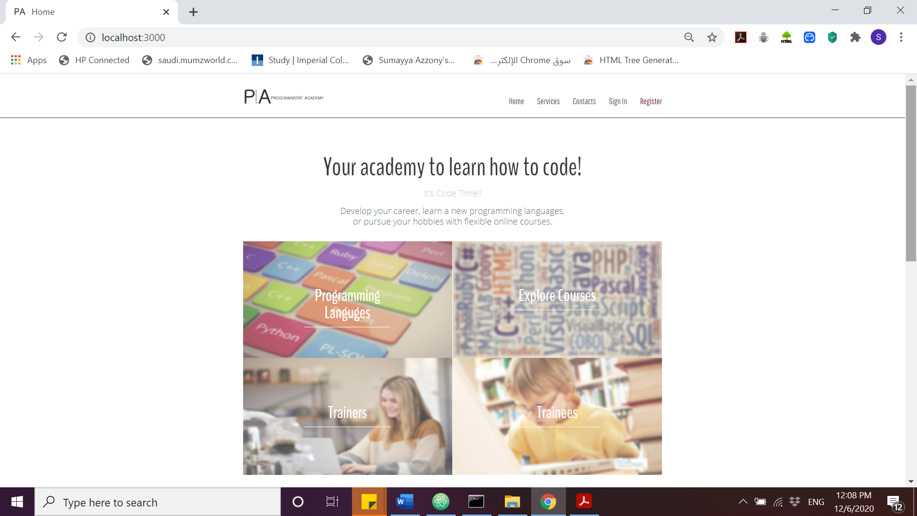

Figure 2: Home page above side

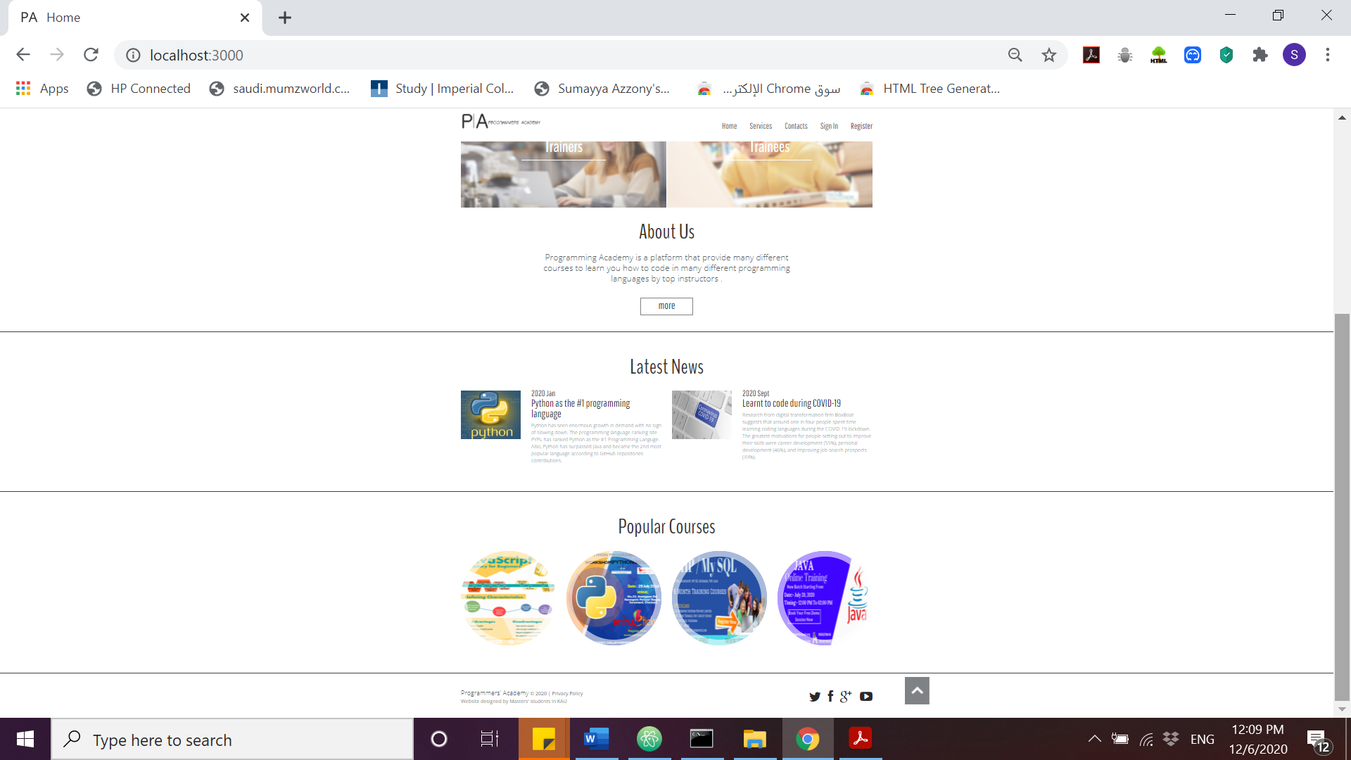

Figure 3: Home page down side

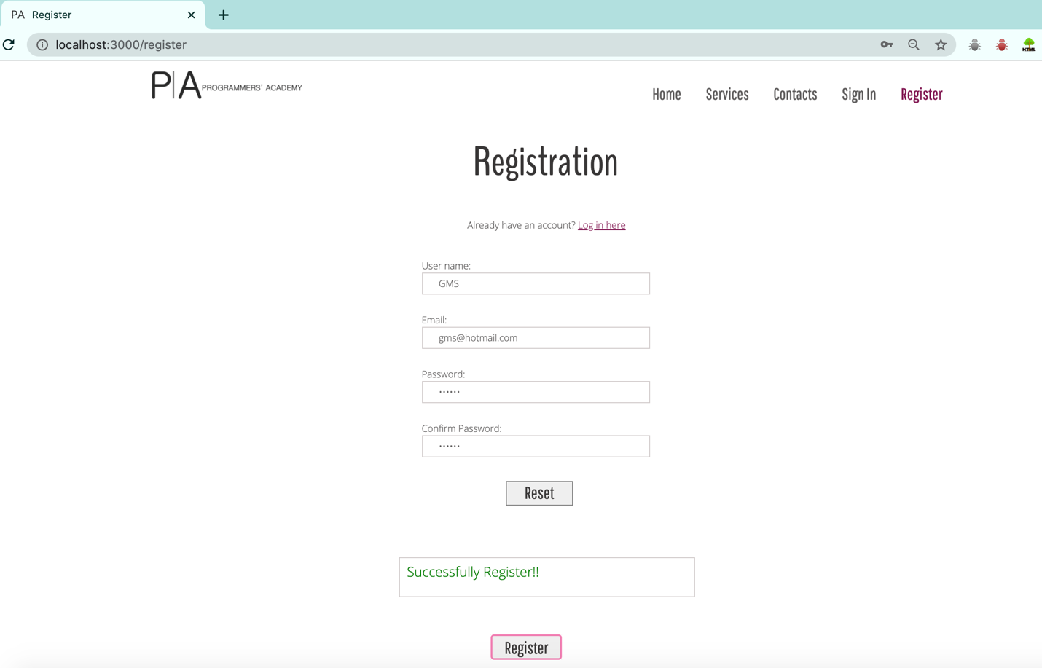

Figure 4: Register page

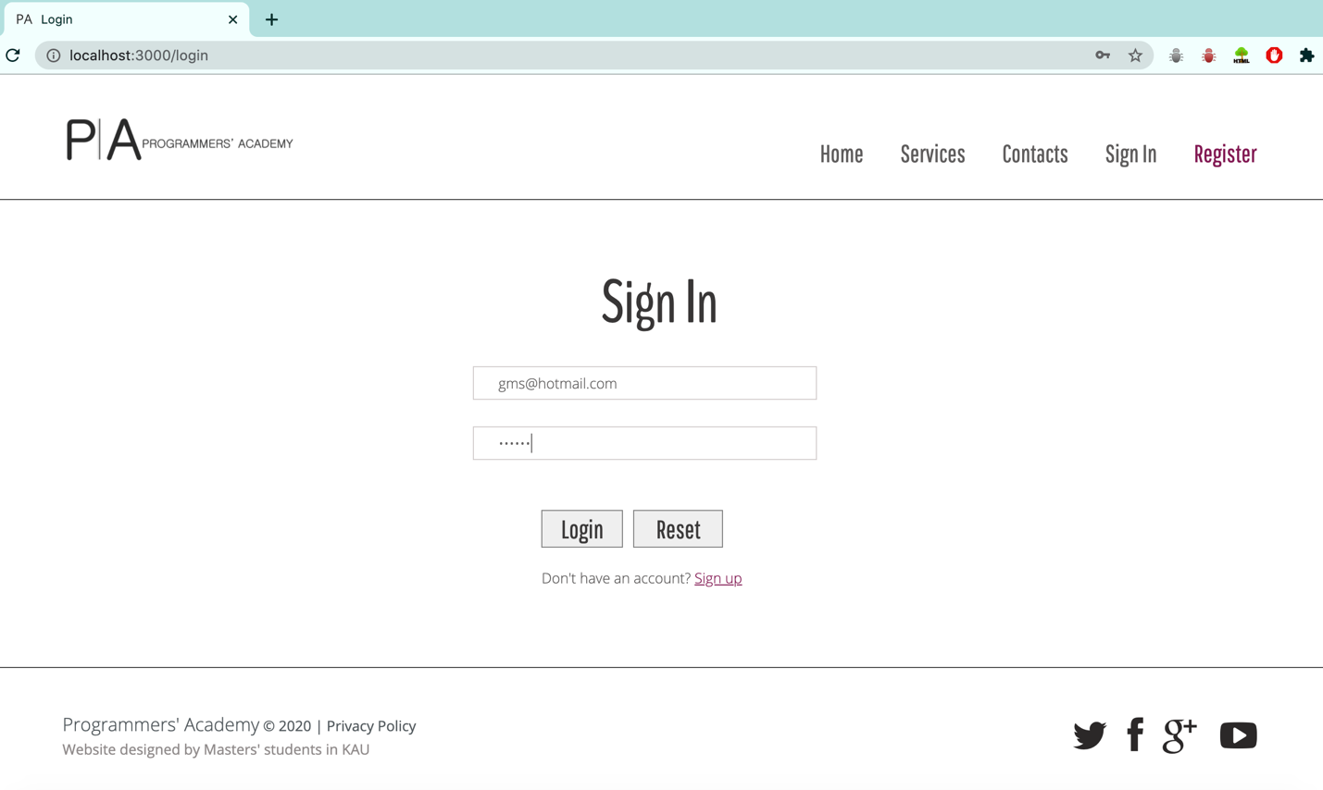

Figure 5: log in page

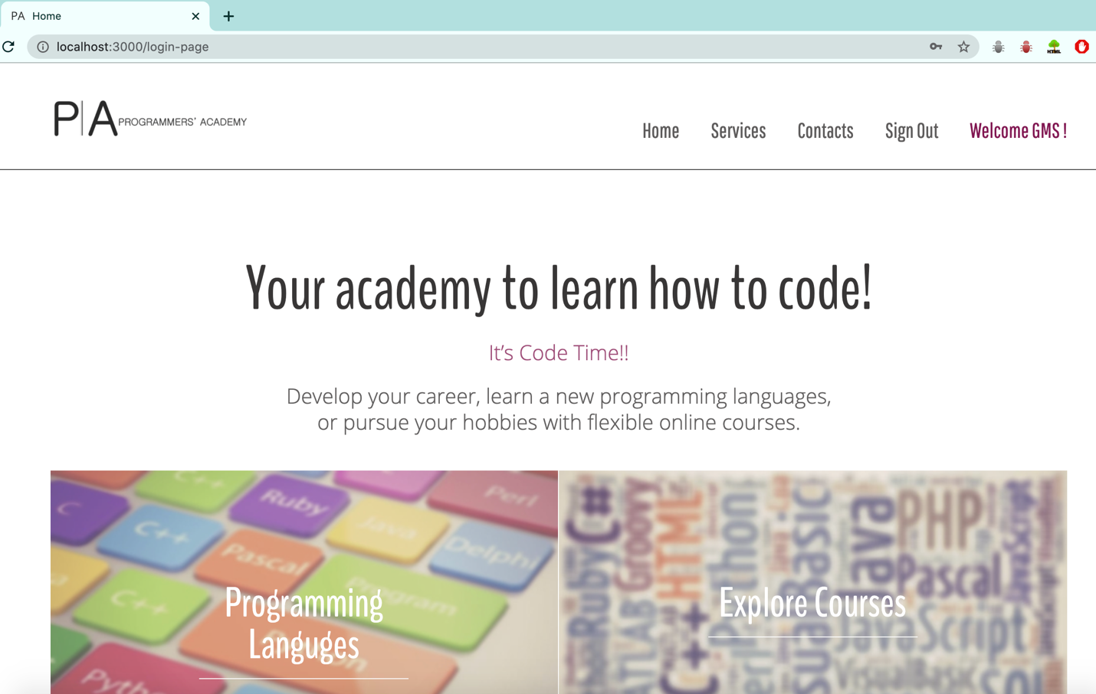

Figure 6: page after logging in successfully.

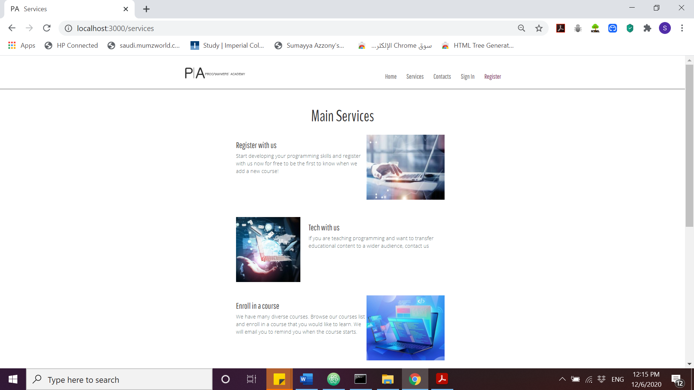

Figure 7: Services page

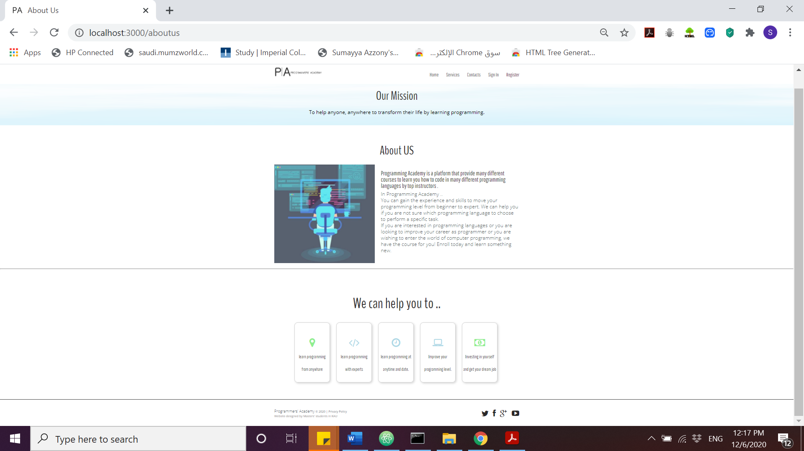

Figure 8: about us page

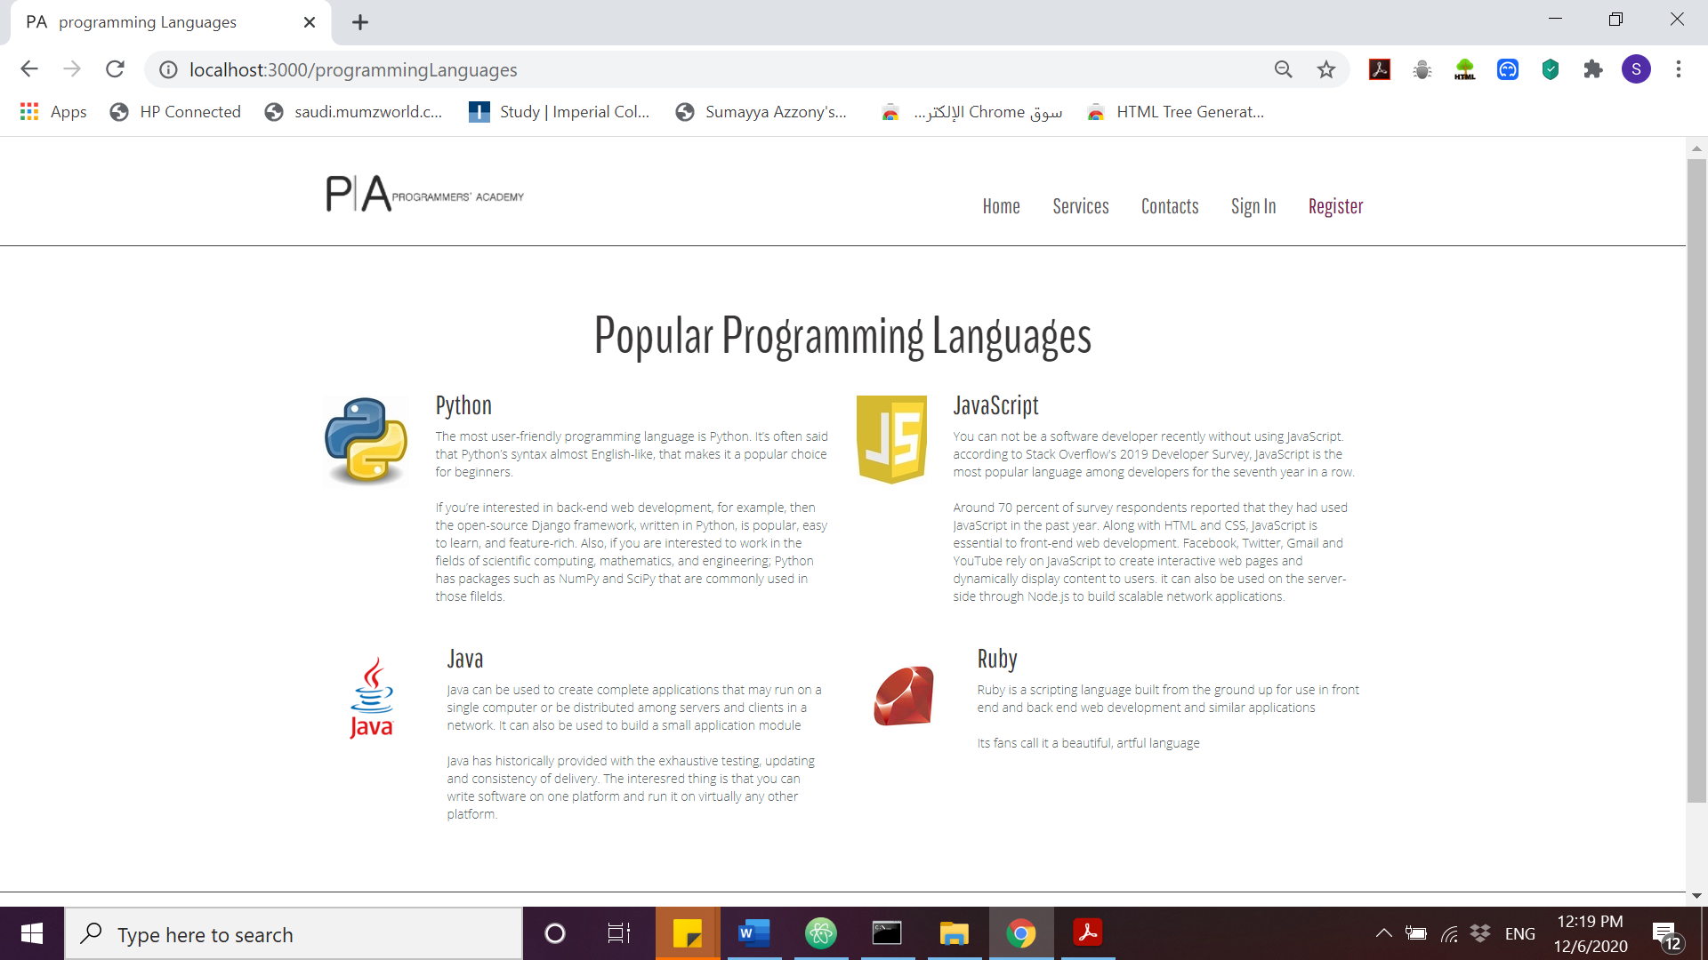

Figure 9: Find more about programming languages

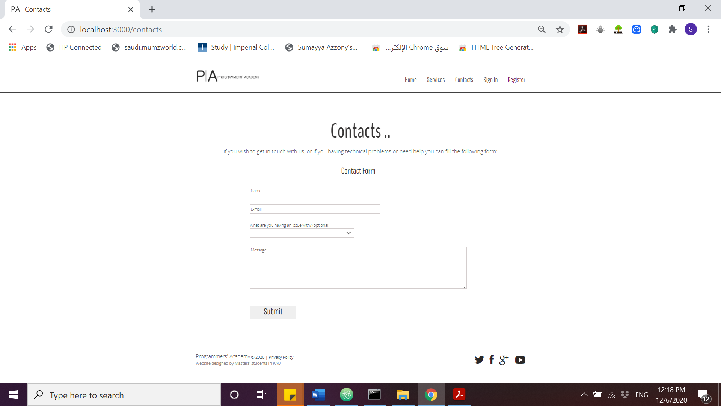

Figure 10: Contact us page

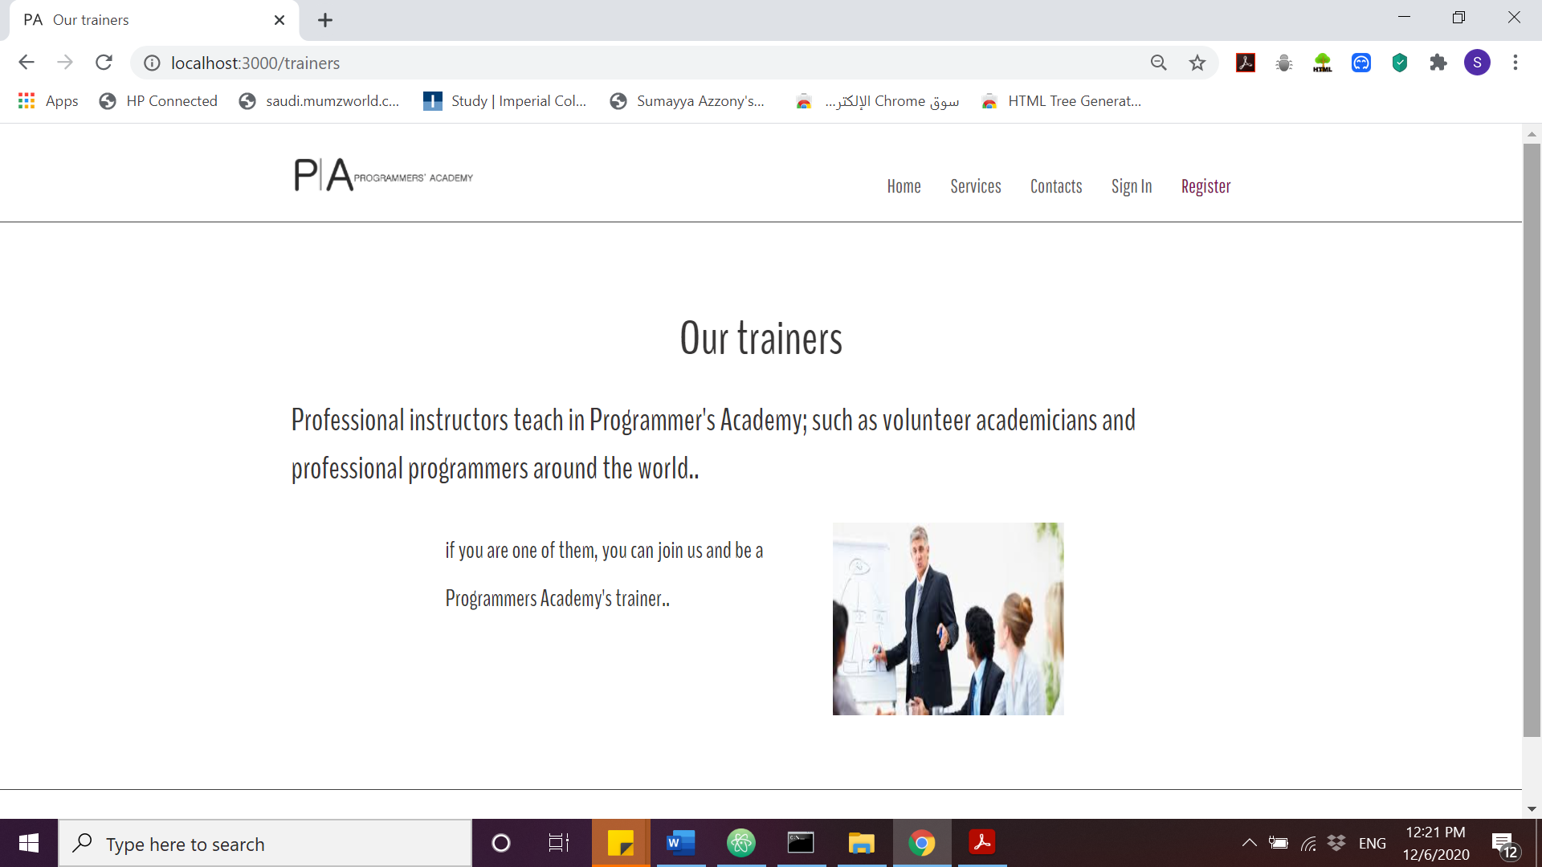

Figure 11: Programmer's academy trainers

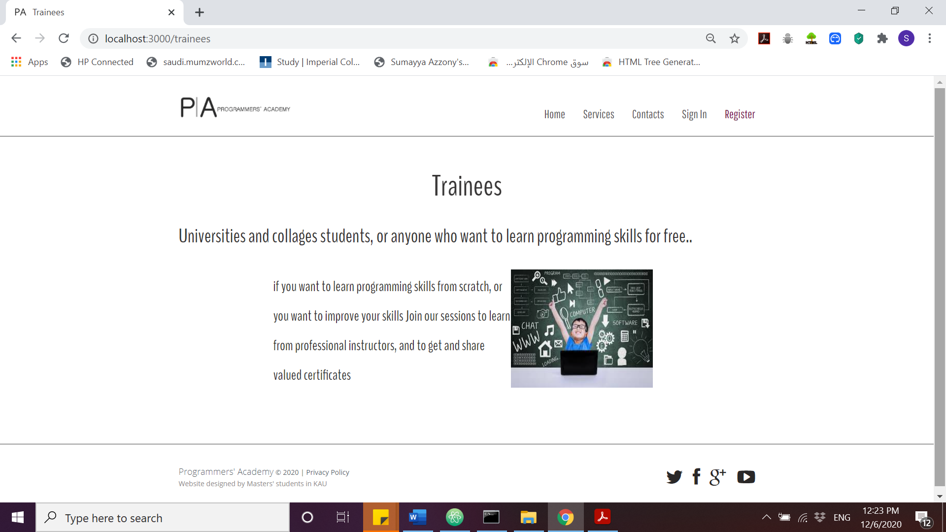

Figure 12: Programmer's academy trainees

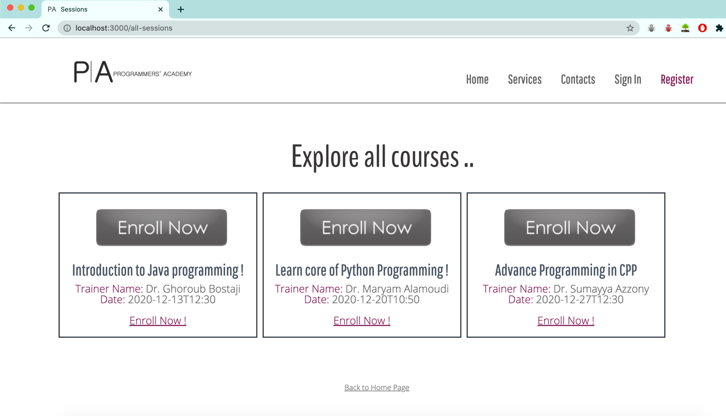

Figure 13: Explore all courses page, enrollment is available.

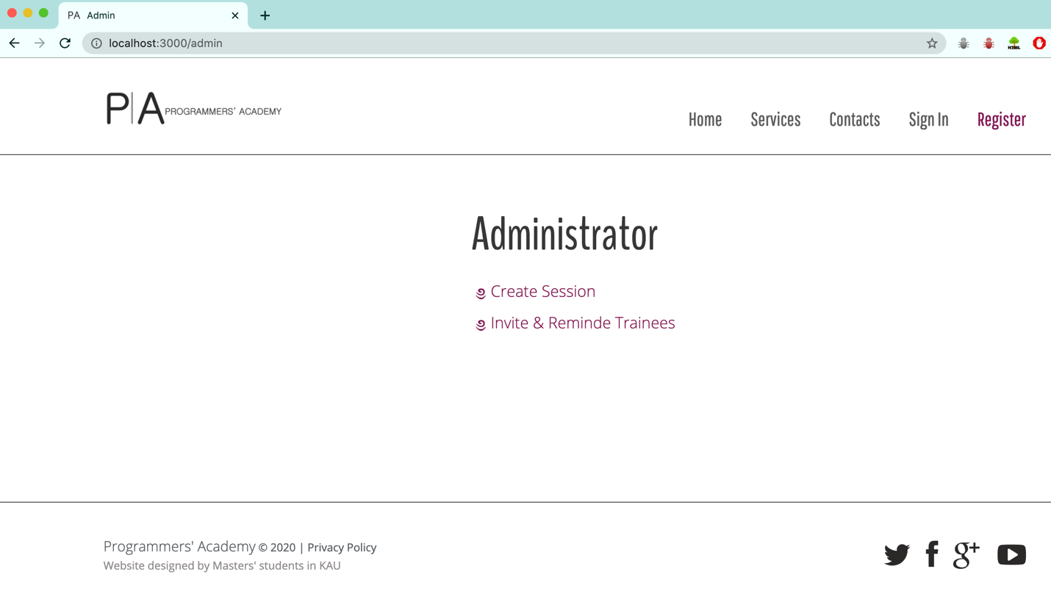

Figure 14: Admin' programmers academy permissions

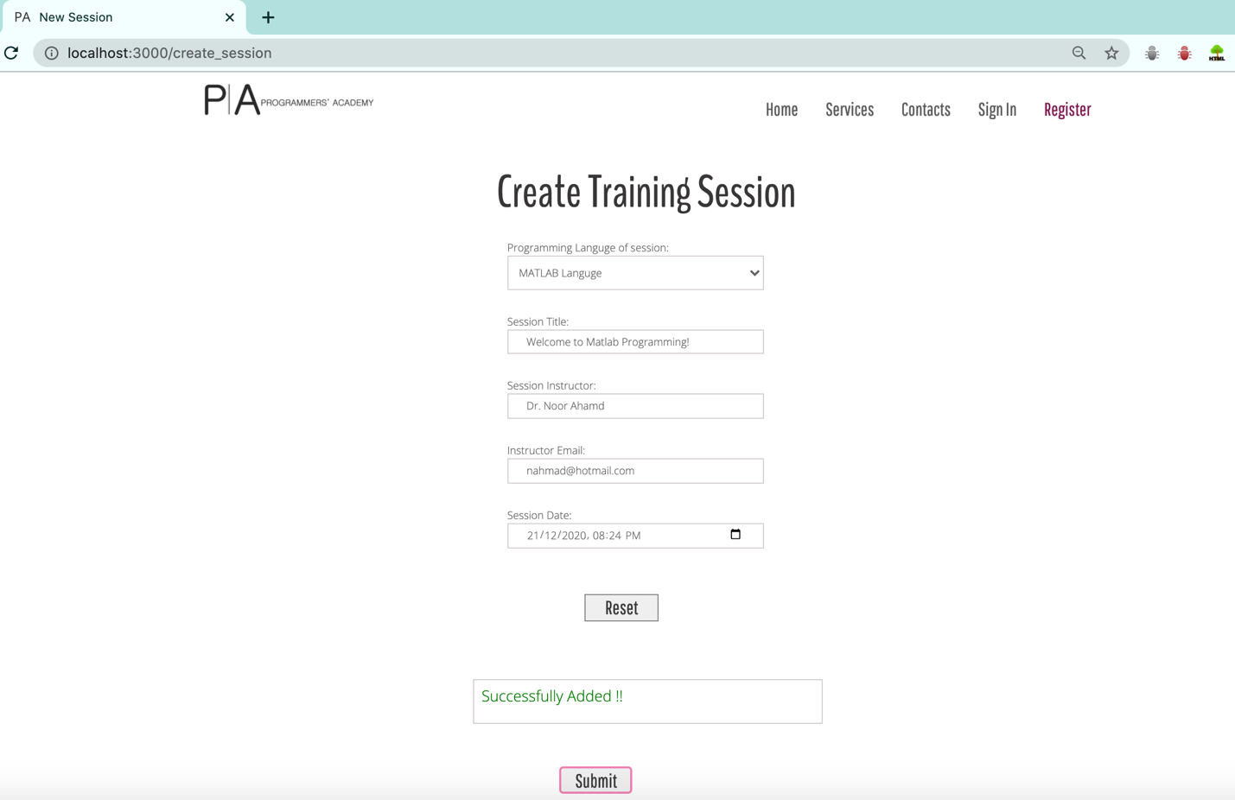

Figure 15: creates session page for admin

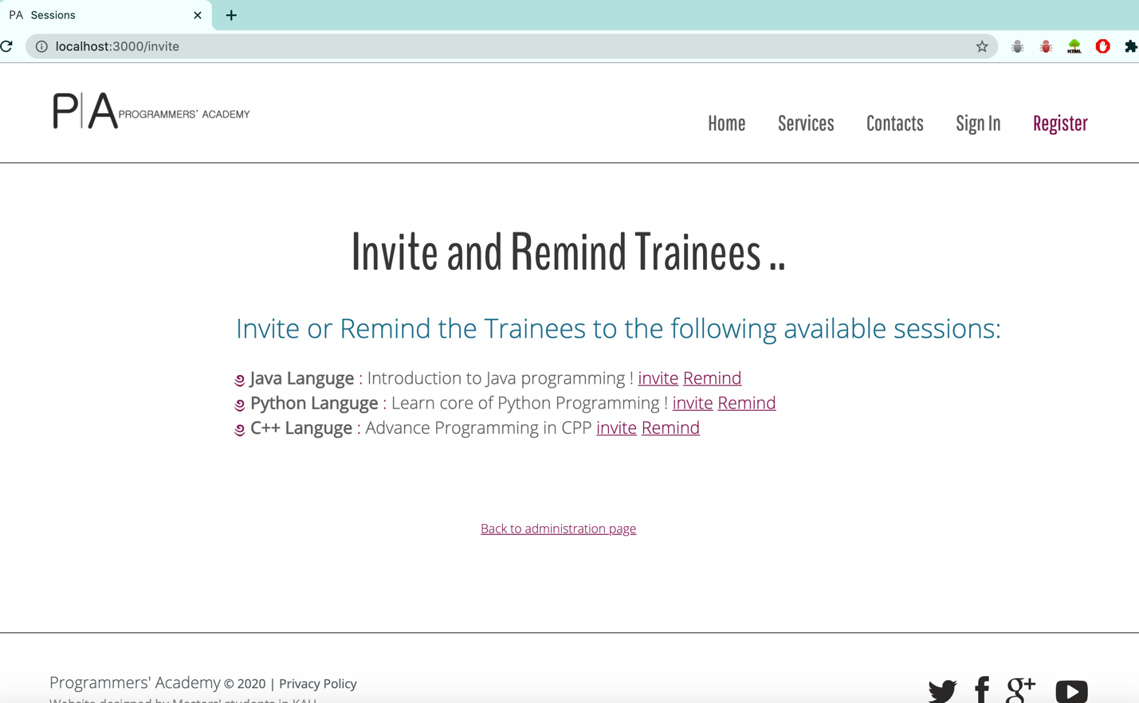

Figure 16: invite and remind trainees by admin

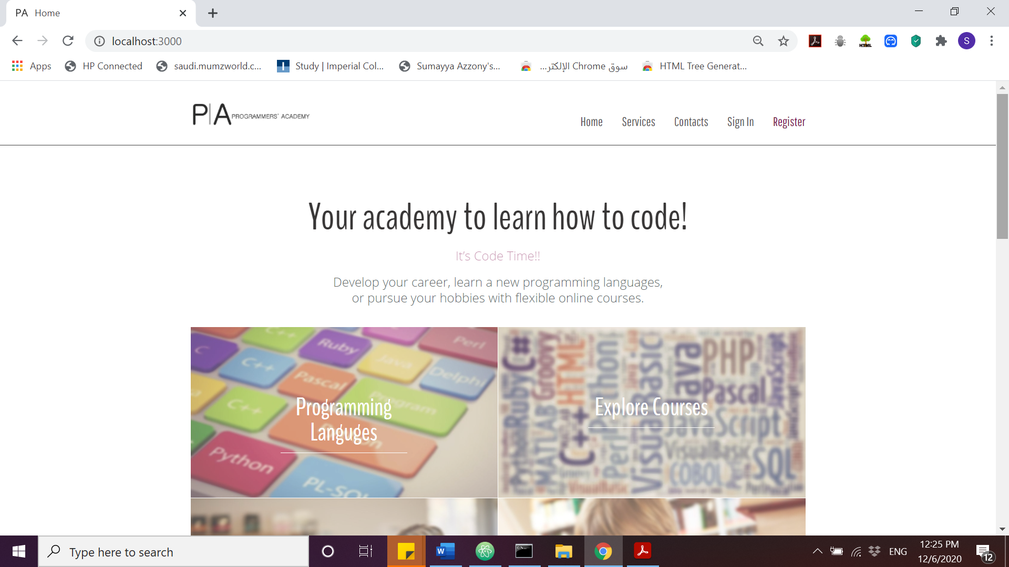

Figure 17: Header for all webpages

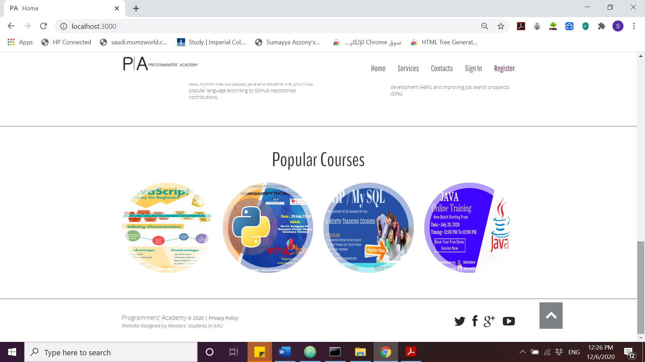

Figure 18: Footer for all webpages

**Below are steps to access and retrieve local ( academydb ):**

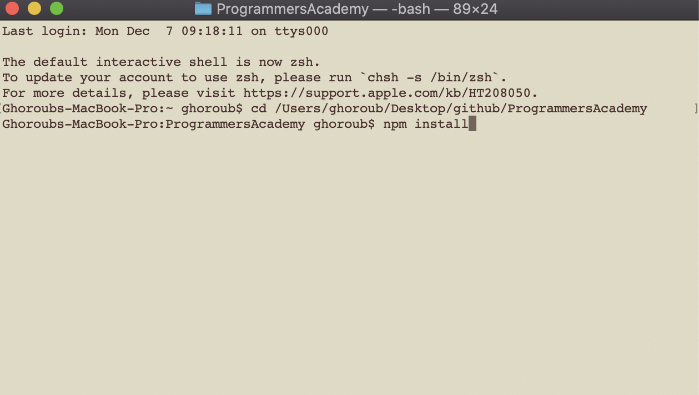

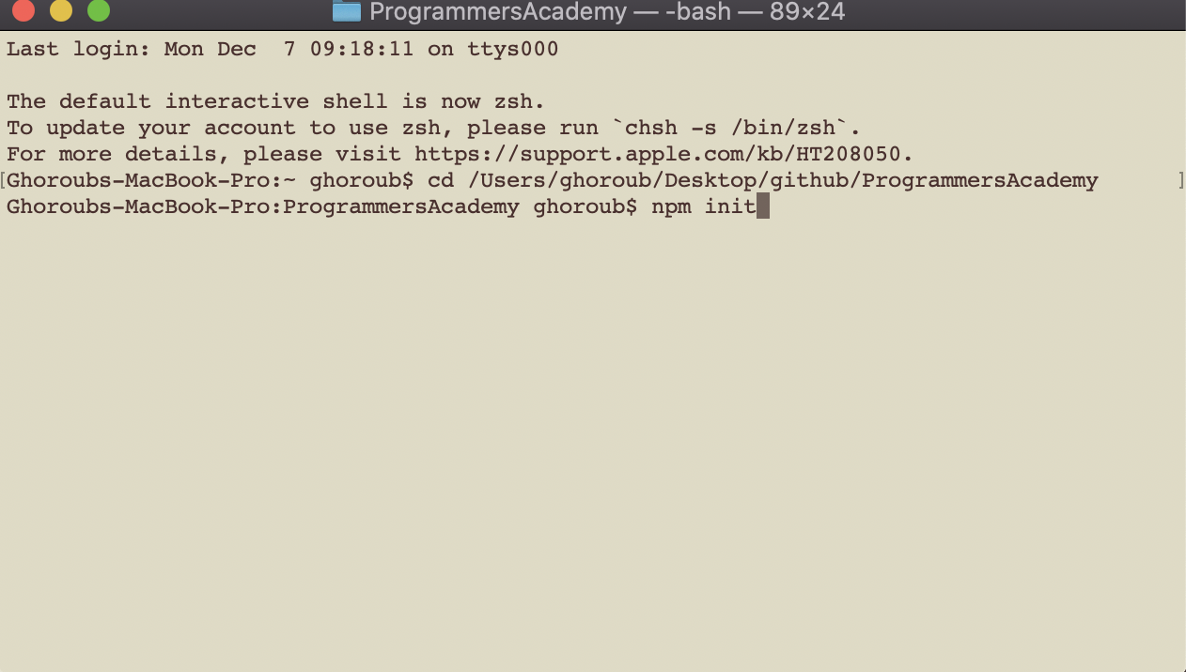

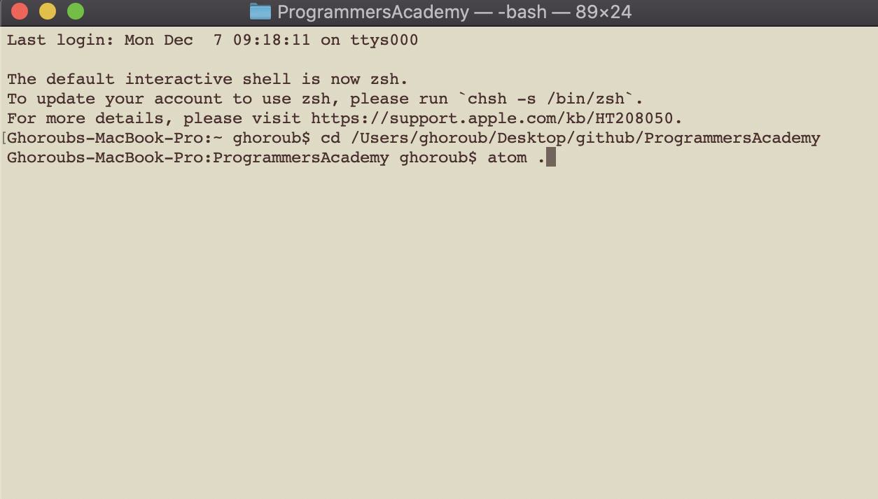

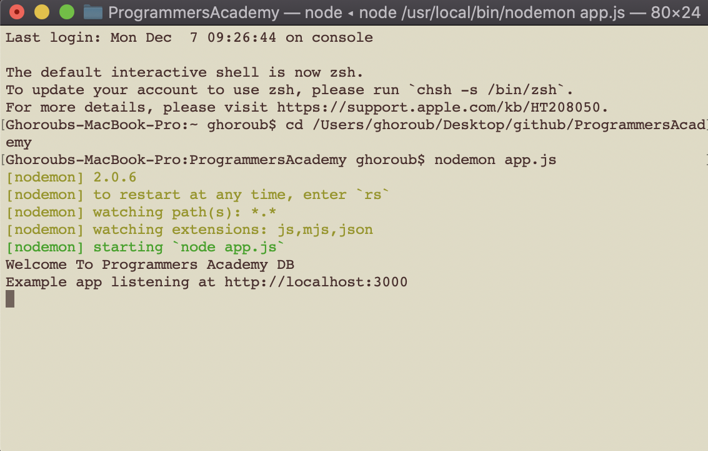

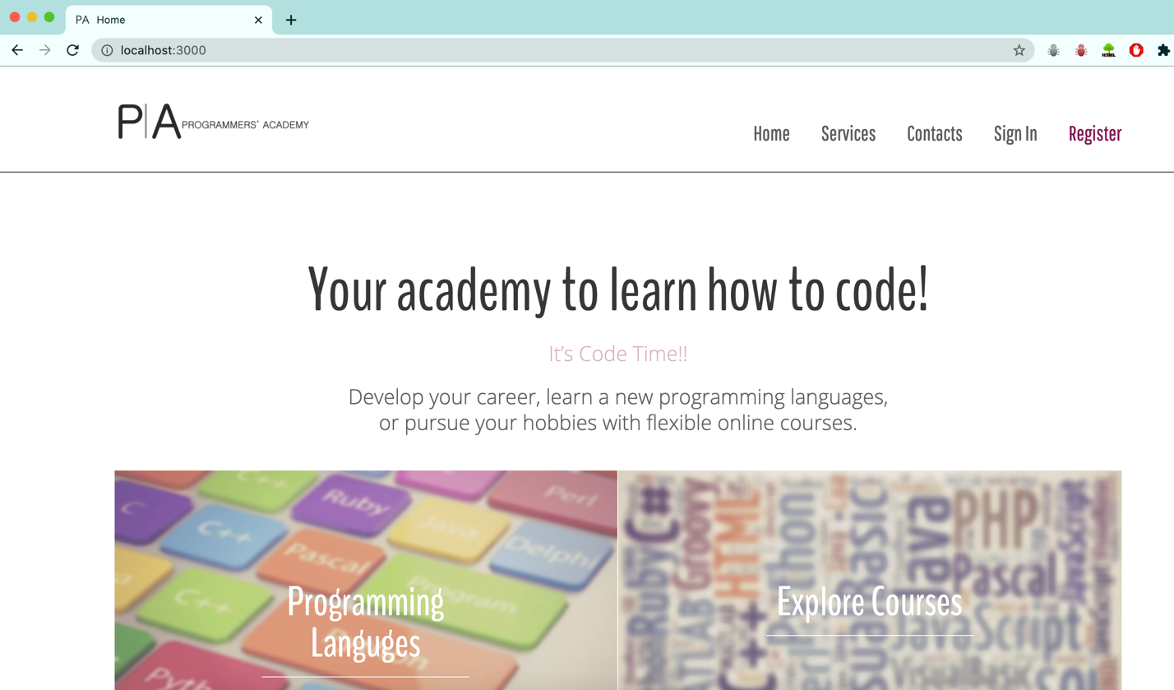

***In the Mongo***

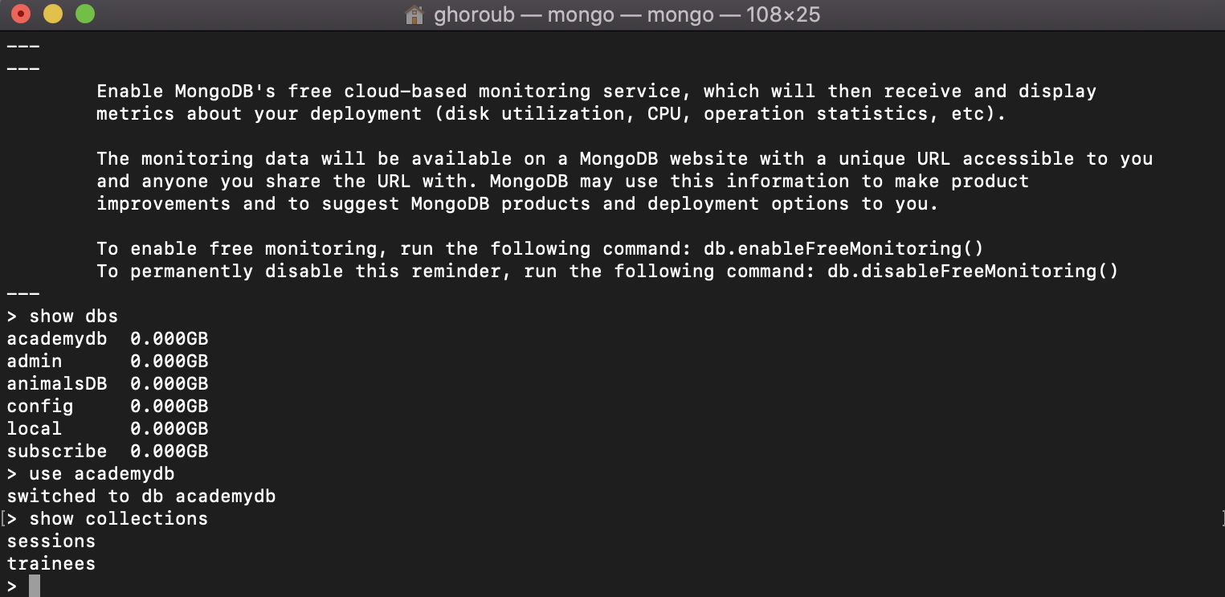

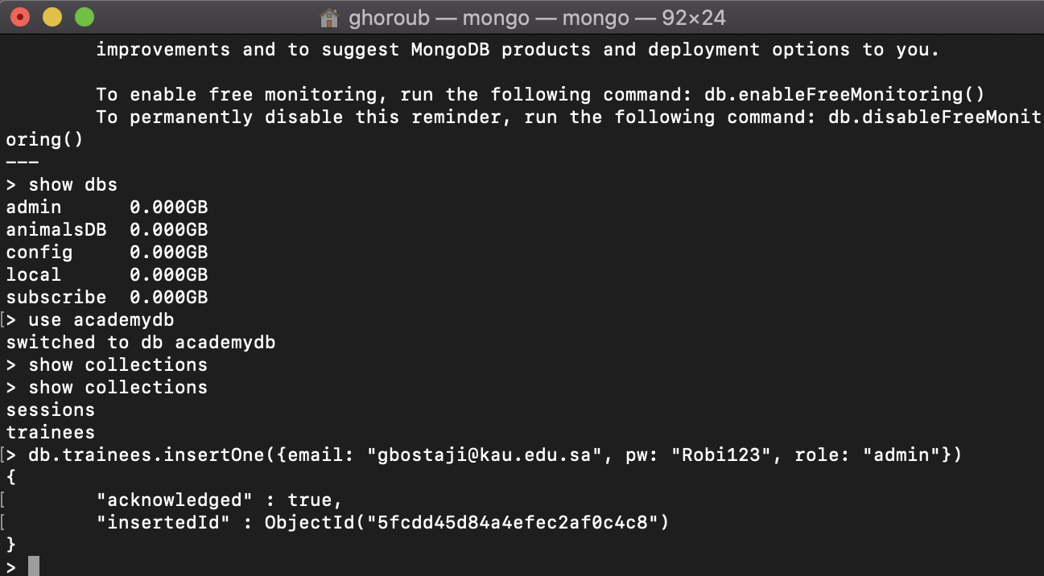

**Task for each member:**

Our Story in building Programmers’ academy project:

# We used to meet once at a week to discuss the ideas, developments and the latest work that we have accomplished through the Zoom platform.

* We decided to employ our project to hold special programming language free courses
* **Summaya** search about a name for the website to be new name (unique name) and create the version 1 logo of the project.
* **Ghoroub** make a GitHub repository and share us to make a clone in our PCs to work in parallel and all the team be updated (fetch, push, and pall) ☺
* We divide the first version of website pages between us to create them by using (bootstrap + jquery + html + css + js ) ( **Summaya**: index.html / **Ghoroub**: login.html + create-session + rigester.html / **Maryam**: aboutus.html + contacts.html) .. without any attractive style ☹
* **Ghoroub** search about a template we can use it to make our website more professional and attractive design, she also makes a new version of logo to replace it with the template logo. And she makes the small icon that appears beside the title of webpage.
* After that, we meet on the zoom to divide the updated pages of the web site and placement the first version of our work in the chosen template.
* All the team change the pages from .html to. ejs
* **Maryam** pages (index + services + profile + contacts + about-us) **Summaya** pages (index + programming-languages + trainees + trainers) / **Ghoroub** pages (index + invite + create-session + admin + all-session + login + register)
* In backend we work together and tray to work continuously to solve the errors that we were facing when we try to program the features of the system
* **Summya** wrote the report, and **Ghoroub** worked on the demo and enter the data to database and take the screenshot for the doc and Maryam worked on presentation
* We try to learn more by our self in (ajax, sent email to invite or remind, role of different users, ejs)